Group 14: K-Nearest Neighbors(k-NN) Classification / Regression
Members: Zach Pohlman, Alex An, Trent Gregory

The K-NN Algorithm
K-Nearest Neighbors, or K-NN, is a supervised machine learning algorithm that classifies or predicts outcomes based on the majority class or average value of its nearest neighbors. Unlike deep learning models, K-NN is simple, intuitive, and often used as a baseline for classification and regression tasks.

1. Lazy Learning
Because K‑NN doesn’t train a model, it’s computationally light during training but heavier during prediction. This makes it great for smaller datasets but less efficient for very large ones. The trade‑off is flexibility — it can adapt instantly to new data.
“Lazy” algorithms also have the issue of having a higher power-cost due to storing the entire dataset and executing it every time a prediction must be made. This issue can increase when the data is sparse, complex, or in situations where the training data is expected to change frequently.
Ideally, Lazy algorithms should be utilized where response time is not a critical factor.

2. Distance Metrics
The heart of K‑NN is distance measurement. Imagine plotting points on a graph — the closer they are, the more similar they’re considered. We can measure this closeness in different ways: Euclidean distance (straight line), Manhattan distance (grid‑like path), or Minkowski distance (a generalization). Choosing the right metric can change the results significantly so for our implementation we would probably pick the “safest” option which would be the Euclidean distance measuring.

3. Choosing K
The parameter K determines how many neighbors we consider when making predictions. For classification, we use majority voting. For regression, we average values. Choosing K-value can be tricky as, if the value is too small, the model may be sensitive to noise; too large and it is overdamped. In addition, we should aim to pick an odd K-value to avoid ties during regression.

4. Issues
There are issues that can be present in K-NN algorithms, some unique, some not. For one, K‑NN is sensitive to feature scaling. If one variable has a much larger range, it dominates the distance calculation. That’s why normalization or standardization is essential. Irrelevant features also reduce accuracy, so preprocessing is critical.
Alternatively, if the data selected only contains one feature, then feature scaling is not necessary for the program, resulting in a single variable regression.
If normalization is not performed, there is the potential of class imbalance, where the dataset may have significantly more examples in majority classes than in the minority classes in a dataset, causing the K-NN model to favor the majority class, leading to poor performance on crucial minority classes.

The Dataset used
The datasets we selected, Iris.csv and Diabetes.csv, are widely accessible datasets that are famously used for testing algorithms. They contain enough data and sections to separate data into multiple constraints with one target variable. Diabetes.csv was originally gathered from the National Institute of Diabetes and Digestive and Kidney Diseases. The objective of this dataset is to diagnostically predict whether a patient has diabetes based on certain diagnostic measurements included in the dataset.

Preprocessing
Before applying K-NN, preprocessing is essential. We load the raw data from CSV or Excel files, identify attributes, and ensure proper formatting. Because K-NN relies heavily on distance metrics, we normalize or standardize features to prevent larger ranges from dominating the calculations. We also check for irrelevant features that could reduce accuracy. In terms of normalization, the numerical data is changed to the formula of (x - min_val) / (max_val - min_val), with min_val and max_val being dependent on the statistical data calculated from the list of data.

How to Run the KNN-Algorithm:
1.Open Python Notebook in a compatible environment.
- Executing through Colab and/or Jupyter
2.Make sure your environment supports the required libraries.
3.Run all cells, and analyze the results.
- If you want to use a different csv file, you can change the algorithm to specify the requested file.
If you have access to the GitHub repository:
- Clone the repository
- In a terminal,
  - pip install -r required_libraries.txt
- Launch Jupiter notebook

Environment settings
The algorithm relies on the libraries matplotlib, Ipython, numpy, panda, math, csv, heapq, and random. It is advised to make sure your environment has the libraries installed.

Results
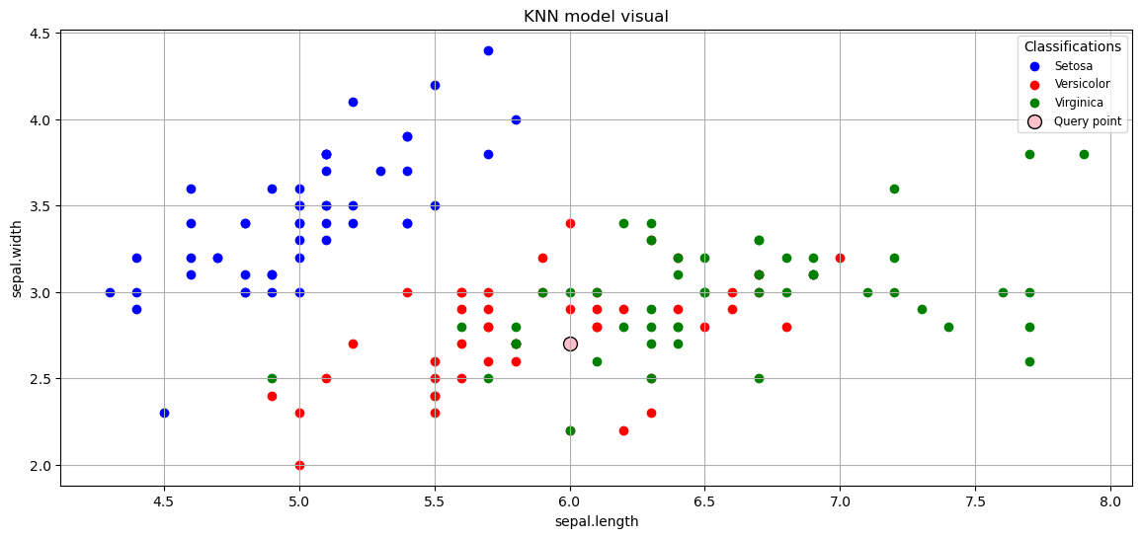Table 1: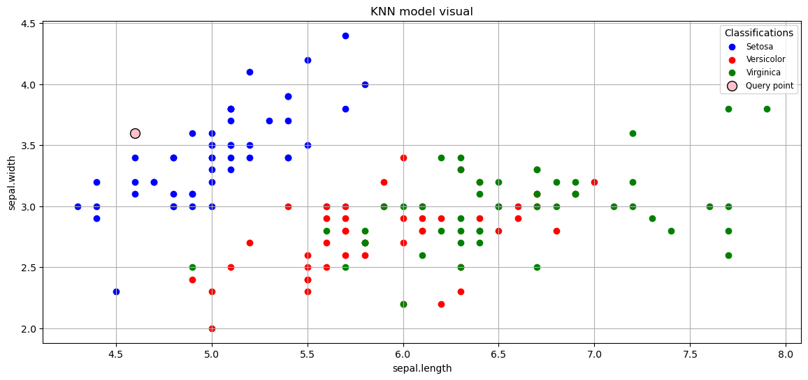Table 2: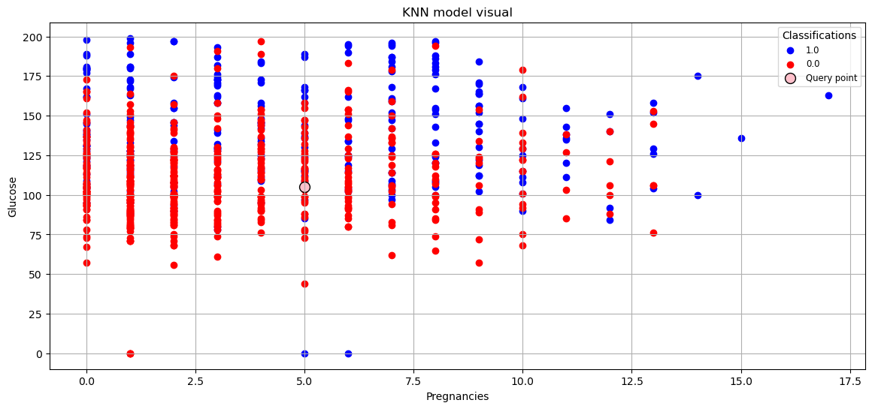
Table3:

Analysis
For the Iris dataset, as shown in table 1, our model achieved around 90–100% accuracy, depending on the chosen K. The datapoint in Table 2 was of a separate test, and that one was randomly selected to be of the Versicolor class. Using closest neighbors for identification, the model classified the point into the Versicolor class. For the Diabetes dataset, as shown in Table 3, predictions aligned well with actual outcomes, showing the model’s reliability in medical diagnostic contexts.

